# 1).Write an assembly language program to perform multiplication of 8-bit data.

CODE:

org 100h mov al,07h mov bl,08h mul bl

mov bl, al

mov ah, al and ah, 0F0h shr ah,4

add ah, 30h cmp ah, 39h

jle print_first_digit add ah, 7

print_first_digit: mov dl,ah

mov ah,02h int 21h

mov ah, bl and ah, 0Fh add ah, 30h

cmp ah, 39h

jle print_sec_digit add ah,7

print_sec_digit: mov dl,ah

mov ah, 02h int 21h

mov ah,4Ch int 21h

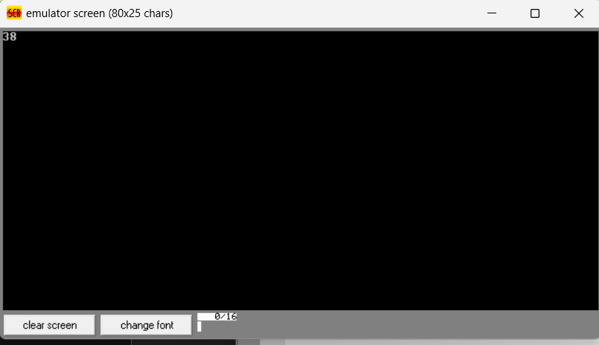:::OUTPUT:::

# 2. Write a program in assembly language to perform multiplication of 16-bit data.

CODE:

org 100h

mov ax,1580h mov bx,1025h mul bx

mov bx,ax mov cx,dx

mov ah,ch and ah,0f0h shr ah,4 add ah,30h cmp ah,39h

jle print_high_nibble add ah,7 print_high_nibble: mov dl,ah

mov ah,02h int 21h

mov ah,ch and ah,0fh add ah,30h cmp ah,39h

jle print_low_nibble add ah,7 print_low_nibble: mov dl,ah

mov ah,02h int 21h

mov ah,cl and ah,0f0h shr ah,4 add ah,30h cmp ah,39h

jle print_high_nibble1 add ah,7 print_high_nibble1: mov dl,ah

mov ah,02h int 21h

mov ah,cl and ah,0fh add ah,30h cmp ah,39h

jle print_low_nibble1: add ah,7

print_low_nibble1: mov dl,ah

mov ah,02h int 21h

mov ah, bh shr ah, 4 add ah, 30h cmp ah, 39h

jle print_high_nibble2 add ah, 7 print_high_nibble2: mov dl, ah

mov ah, 02h int 21h

mov ah, bh and ah, 0fh add ah, 30h cmp ah, 39h

jle print_low_nibble2 add ah, 7 print_low_nibble2: mov dl, ah

mov ah, 02h

int 21h

mov ah, bl shr ah, 4 add ah, 30h cmp ah, 39h

jle print_high_nibble3 add ah, 7 print_high_nibble3: mov dl, ah

mov ah, 02h int 21h

mov ah, bl and ah, 0fh add ah, 30h cmp ah, 39h

jle print_low_nibble3 add ah, 7 print_low_nibble3: mov dl, ah

mov ah, 02h int 21h

mov ah,4ch int 21h

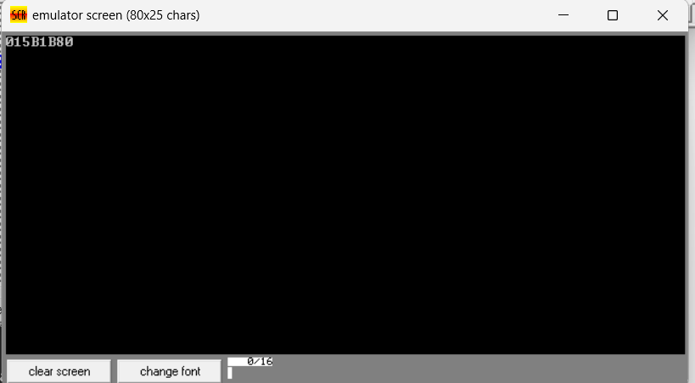:::OUTPUT:::